A Message from the Board of Directors

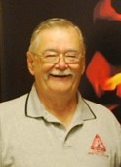
Once again, it is a sad duty to announce that another member of the IFIA has passed away. Jim Plunket died on March 12th. Jim worked in fire service for over 30 years, including 17 years as a Lombard firefighter and paramedic. He retired in 1996 went on to serve as their Public Education Coordinator, a role he was extraordinarily passionate about. He was a volunteer at the Belmont Fire District, was a Trustee at the Darien/Woodridge Fire Department.

In its infancy, Jim was extremely active with the juvenile firesetters program in the State. He was also extremely visible with the fire services exhibit at the State Fair. Often, he would volunteer to work it for its full duration. His passion for fire safety will be missed.

Following a two-year absence, we are again starting to meet in person. March’s Fire and Life Safety Conference was our first annual conference in three years. We did not know what to expect, but were excited that over 100 attendees, and 23 exhibitors at our showcase, showed up. The sessions were well received, and the keynote address by retired Chief Pat Kenny was powerful and moving.

We will regroup in June to start thinking about the 2023 conference. If you have any ideas on topics or speakers, make sure you email them to our office.

For those looking for a Fire Inspector 2 class, one will be held in Huntley on Fridays, beginning May 6.

A fire Inspector 1 class will be held in Glenside in August. Registration information for both classes is on our website.

The IFIA is looking for instructors for the Office of the State Fire Marshal (OSFM) Fire Inspector 1 and 2 certification classes. If you have an interest in teaching these classes, submit a resume to our Office at ifiafire@illinoisfireinspectors.org.

On an average, the IFIA presents two Fire Inspector I classes and one Fire Inspector II class per year. These classes rotate around the Chicago metropolitan area. Each class is five days long, eight hours each day. An instructor typically teaches only one day, and they are paid for their instruction time.

The minimum requirements to instruct are:

OSFM Fire Inspector I Class
OSFM Instructor I certification
OSFM Fire Inspector I or OSFM Fire Prevention Officer 1

Preferred certifications: OSFM Basic Fire Prevention Officer

OSFM Fire Inspector II Class
OSFM Instructor I certification
OSFM Fire Inspector II

Preferred certifications: OSFM Advanced Fire Prevention Officer

In lieu of the above qualifications, you can be considered a Subject Matter Expert. In order to do so, you will need to submit your resume of qualifications and a cover letter. Your cover letter will need to provide an explanation of why your experience is equal to, or exceeds, the above requirements.

If you have any questions, you can email us at ifiafire@IllinoisFireInspectors.org

There will be a Youth Firesetter Class in Madison on Saturday and Sunday, May 21 – 22. THIS IS A WEEKEND CLASS! Go to https://www2.illinois.gov/sites/sfm/Events/Pages/Youth-Firesetter-Interventionist-Class.aspx to register and for more information.

There will also be a class in Calumet City. The class will be Thursday and Friday, June 2nd and 3rd. Go to https://www2.illinois.gov/sites/sfm/Events/Pages/Calumet-City-Youth-Firesetter-Intervention-Class.aspx to register and for more information.

To see the latest in the State for CRR, visit their website at www.illinoiscrr.com. For those on Facebook, they have a page on there as well for you to follow. Just enter Illinois Community Risk Reduction in the search box.

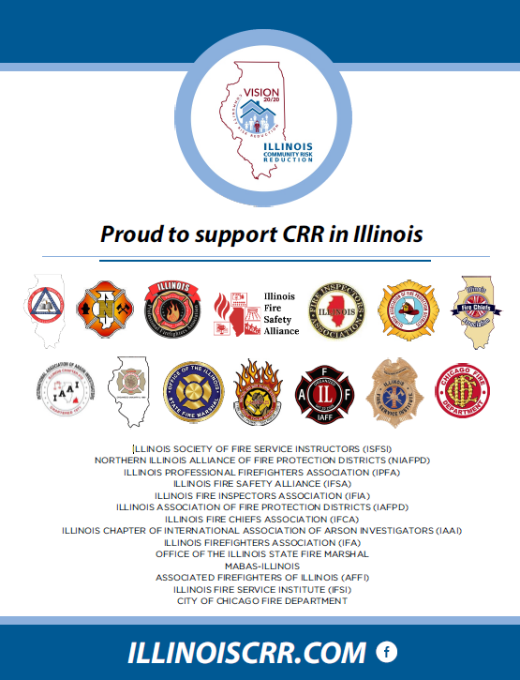

Check the website for the following upcoming events:
April – Mini-seminar with the OSFM divisions
April/May – Fire and Life Safety Educator OSFM class at Countryside
May – Fire Inspector 2 at Huntley
June – Mini-seminar – IFC update
August 21 – Fire Safety Exhibit at the State Fair
August – Inspector 1 at Glenside
November – “Did You Know” mini-seminar

